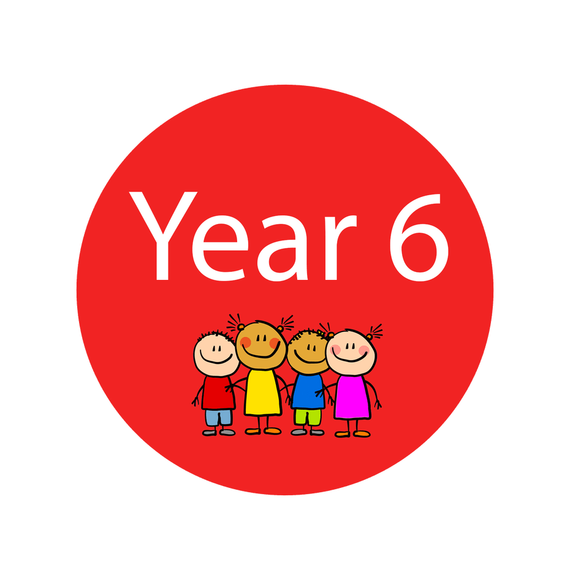
Dear Year 6
I hope you and all your families are all feeling ok, staying safe and getting used to a different way of living for a short while. This is certainly a time in all our lives we will never forget and a time that will go down in history, so make sure you make some very special memories as you will be telling people all about this, and what you did, when you are old and grey!
We all need to get into a different routine for a little while and it might take a little time to get that right. What works for one family might not necessarily work for another, especially as many parents are trying to work from home and look after children of different ages all at the same time.
It is certainly very strange not seeing you all every day, not having all our chats and laughs, and not finding out what you are all up too. But I am thinking of you all the time and I know you will all be trying your best to adapt to being at home for a little while, and make the most of this unusual time. It may seem strange but is also a great opportunity to do things you might not get the chance to do usually. Think about what you are really interested in and find out all about that subject: maybe its studying space or animals or kings and queens from history or the growing pollution problems we face. Whatever you are interested in now is a fantastic time to become a real expert in it!
Try really hard to achieve something every day. Make your own fun timetable and add lots of different activities to it; things that you really enjoy: such as learning to draw, learning to cook or bake, learning yoga, reading lots of books. There are so many activities you now have the opportunity to do, as well as the subjects you would usually do at School. Having a routine you follow each day is really important….not forgetting break times of course!

I would really encourage you to keep a diary of what is happening, what you are doing and how you are feeling at least a few days each week. You could include what the government are enforcing and how it is affecting our lives and also why it is so important that we follow the advice we are given.
Your Maths skills are phenomenal so really keep practising all the fantastic learning and progress you have made this year – remember use it or lose it!
Read every day!! Take time out to relax and read….there are many links on the School’s Website that provide eBooks you can access for free as well as audible books to listen to. David Walliams’ are very entertaining!
Although you have lots of learning that you have taken home with you, I will also load activities on to the School’s website page soon and email some activities to you at times. Please do not feel you need to complete all of them but try to include some at least a few times each week.
Try to get out for a walk or run each day too, (remembering to keep a good distance away from people) exercise and fresh air is really important and always makes you feel better.
Keep in touch and let me know how you are. Stay safe and try and settle in to this new way of living – remember its only for a little while – before we know it we will be back to School and back to homework at weekends!!
Below is a timetable of little positive things you could do each day. Yesterday we made a rainbow and stuck it in our window so that when anyone walks past it hopefully will make them smile.
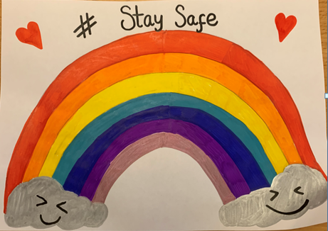

Take care and I hope to hear from you soon.

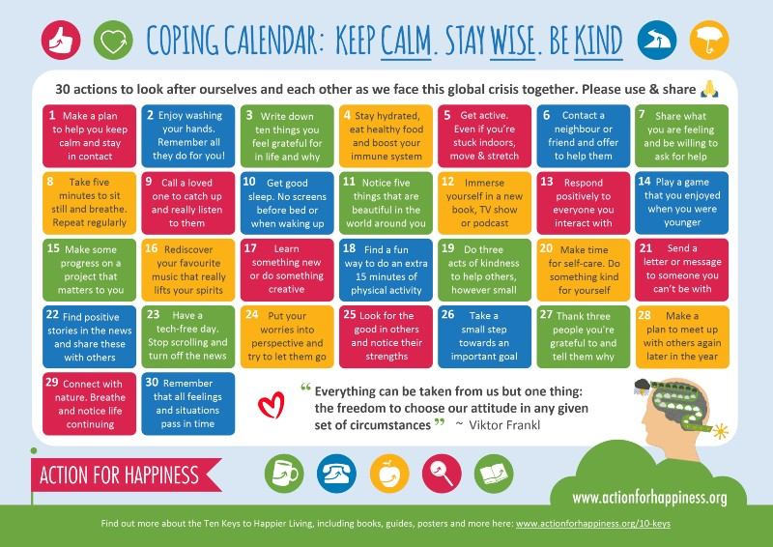
Mrs Davies xxx

