Autumn Learning
Maths
In our maths lessons we will begin with looking at the place value of numbers up to 10,000! We will learn to represent numbers in different ways, partitioning, using number lines, comparing and ordering numbers and rounding to the nearest 10, 100 and 1000.

We will then move onto adding and subtracting 4 digit numbers building up to exchanging more than 1 number.

After that, we will look at calculating area followed by using our times table knowledge to multiply and divide using our formal methods.

Throughout all our units, we will be applying our developing knowledge to reasoning and problem solving questions.

English
In our English lessons we will begin by using ‘Roman Invasion: My Story’ and ‘Escape from Pompeii’ to support our learning.
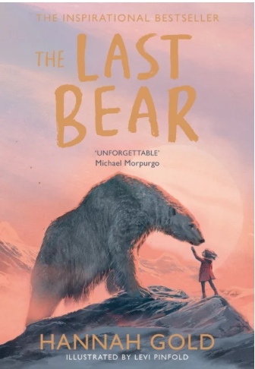
Writing - We will be creating a non-chronological report, a letter, newspaper report, narrative and set of instructions.

SPAG – to improve our writing, we will study nouns, pronouns prepositions and adverbials.

Reading – we continue to develop our VIPERS skills using a variety of texts.

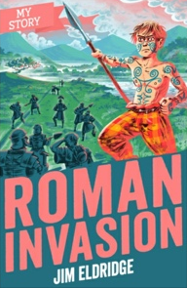
Science
Electricity
We will begin this unit by exploring electrical appliances before moving on to identifying circuit components and explaining what they do. Using our scientific enquiry skills, we will build series circuits, identifying and explaining whether they are complete or incomplete. We will also identify several difference switches and explain how they work in a circuit. We will finish by explaining what electrical conductors and insulators are and give examples of each.

States of Matter
We will begin by looking at solids, liquids and gases, classifying objects and identifying their properties. We will then investigate the weight of a gas and the ideal temperature to melt chocolate! We will explore how water changes state and learning the stages of the water cycle.

Religious Education
Creation and the story of Abraham to Joseph
In this unit we will hear and learn about some important stories from the Book of Genesis. We will explore some important images of God found in these stories and consider what it means for human beings to be made in the image and likeness of God.

Jesus teaches us how to pray
In this unit we will learn about the prayer life of Jesus as he grew up in the Jewish faith. We will study the Our Father, the prayer of the Rosary and some other forms of prayer.

Advent
In this unit we will learn about the ancestors of Jesus and that he was descended from the House of David.

Christmas
In this unit we will study the role of angels in the Christmas story. We will learn about Christians being messengers of Christs’ good news.
DT
Roman Honey Biscuits
We will gain an insight into the history of Roman foods, then investigate and evaluate existing biscuit products. We will create design criteria which we will refer to when designing, making and evaluating our own honey biscuit product. We will use a range of skills and techniques using simple kitchen tools and measuring equipment and we will learn how to shape and cut the biscuits.

Computing
Coding
We will begin by creating a simple computer program using 2Code. Then we will begin to understand how IF statements work and how to use co-ordinates in computer programs. We will also understand what a variable is in programming. Finally we will create a playable game!

Online Safety
We will understand how we can protect ourselves from online identity theft and how any information put online leaves a digital footprint. We will identify the risks and benefits of installing software including apps. We will understand that copying the work of others is called plagiarism and we will consider the consequences. The finish, we will identify the positives and negatives of technology on health and the environment.

Topic
The Romans
We will begin our unit looking at the countries within Europe with then a focus on Italy and its culture. We will then focus on the movements of the Romans, investigate why they invaded Britain, the rebellion of Boudicca, the importance of Hadrian’s Wall and research what life was like in during Roman rule in the West Midlands.

