
What do you think the story of Daniel and the lion’s den teaches us about God?
…………………………………….………………
…………………………………….………………
…………………………………….………………
…………………………………….………………
…………………………………….………………
…………………………………….………………
…………………………………….………………
¹⁸ Dear children,
let us not love with words or speech but with actions and in truth.

1 John 3:18

How can we walk in the footsteps of Christ by being eloquent and truthful?
…………………………………….……
…………………………………….……
…………………………………….……
…………………………………….……
…………………………………….……



What does it mean to be eloquent and truthful?
Eloquent - …………..……………………….
…………………………………………………….
…………………………………………………….
…………………………………………………….
Truthful - ………………………………………
…………………………………………………….
…………………………………………………….
…………………………………………………….

How did Daniel stand up for the truth in this story?
…………………………………….………………
…………………………………….………………
…………………………………….………………
…………………………………….………………
…………………………………….………………
…………………………………….………………

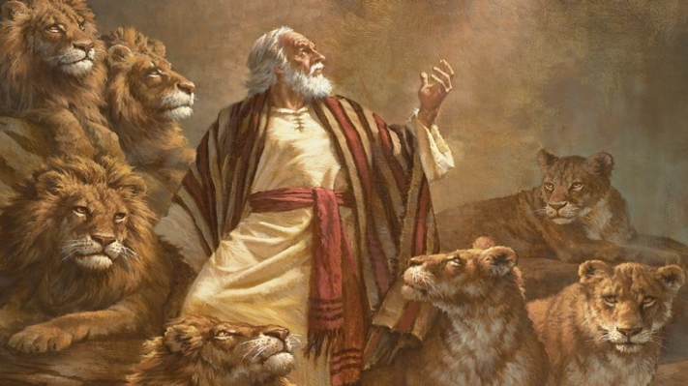

Read the story of Daniel and the lion’s den before answering the following questions as best as you can.

In the beginning of the story, Daniel is described as trustworthy. What does it mean to you to be thought of as a trustworthy person?
…………………………………….………..…………………………………………….……………
…………………………………….………..…………………………………………….……………
…………………………………….………..…………………………………………….……………
…………………………………….………..…………………………………………….……………
…………………………………….………..…………………………………………….……………

Challenge
Use your eloquence to write a letter, make a card or draw a picture for a friend, relative or stranger in a local care home who may appreciate some kind words during this time. Ask an adult to go to
https://facebook.com/dearresidents for more information.

